**Name :**Riham Abdullah Sayed Ahmed ريهام عبدالله سيد احمد

**B.N : 362**

**Date : 3/7/2020**

**Topic :** Programming Languages

**Github link :** <https://github.com/riham-abdullah/html.project.repository>

**Github page :** [**https://riham-abdullah.github.io/html.project.repository/**](https://riham-abdullah.github.io/html.project.repository/)

**Application brief :**

* What is a Programming Language? What is Code?

The code is more like writing a paragraph of instruction or creating a list to do things. Unlike us humans, the to-do list and instructions you write for the computer has to be very detailed and written with some logic.

With code and programming, you can make the computer to draw complex shapes and make rich computer graphics, and then make programs that understand game mechanics and help you build games that feel more real. With these programs you can create the most intense and immersive games of all types.

With code and programming, you can make and send content everywhere with your blog and personal website and style your blog to meet your style. You can build tech-driven business solutions and reach a wider range of customer and cater to a big range of needs.

Furthermore, with code and programming, you will be able to create smart home applications, for example an automated pet feeder, a smart mirror or even create a robot that could help around with the house tasks and be your virtual assistant to talk to and understand you.

**Screenshots :**

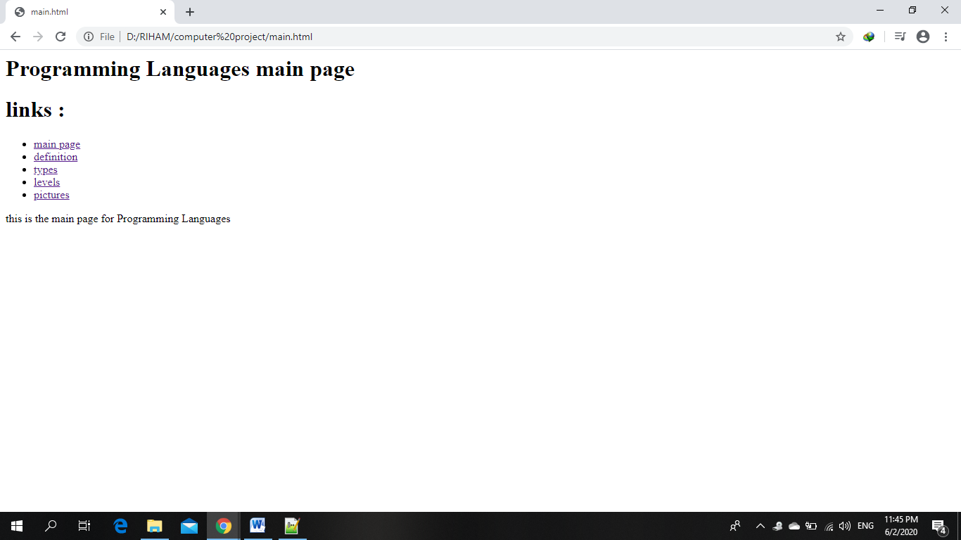

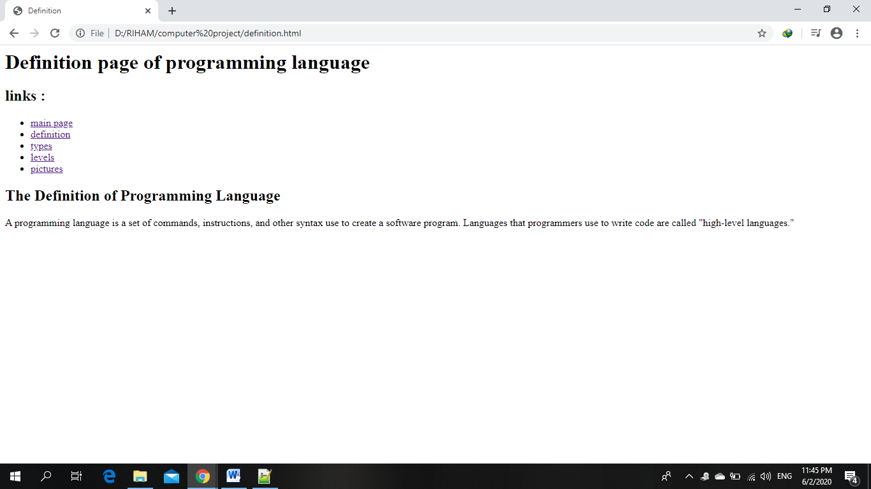

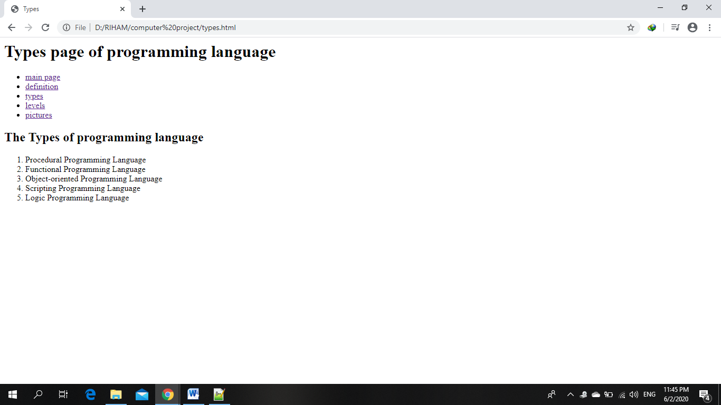

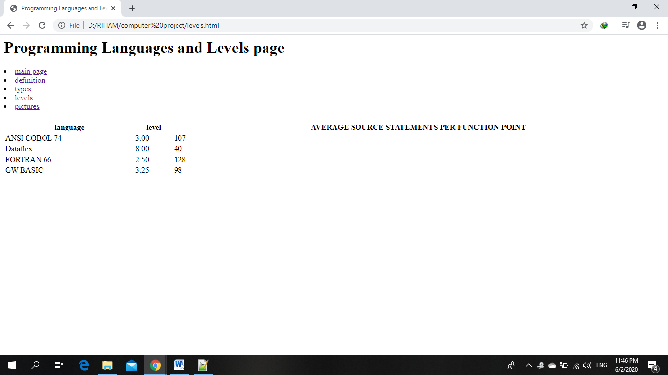

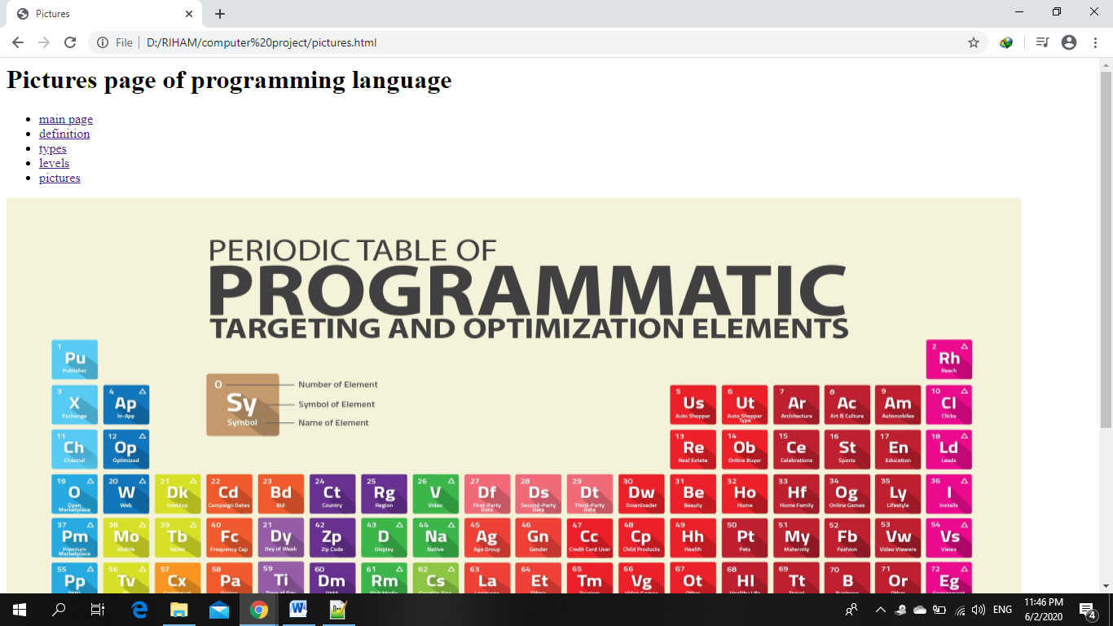

**Source code :**

